Who was Phineas Gage?
Phineas Gage is probably the most famous person to have survived severe damage to the brain. He is also the first patient from whom we learned something about the relation between personality and the function of the front parts of the brain.
As the first newspaper account of the accident reported, that appearing in the Free Soil Union (Ludlow, Vermont) the day after the accident, and here reproduced as it appeared in the Boston Post, Phineas Gage was the foreman of a railway construction gang working for the contractors preparing the bed for the Rutland and Burlington Rail Road near Cavendish, Vermont. On 13th. September 1848, an accidental explosion of a charge he had set blew his tamping iron through his head
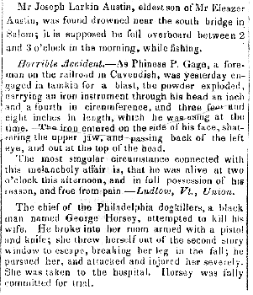 | The tamping iron was 3 feet 7 inches long and weighed 13 1/2 pounds. It was 1 1/4 inches in diameter at one end (not circumference as in the newspaper report) and tapered over a distance of about 1-foot to a diameter of 1/4 inch at the other. The tamping iron went in point first under his left cheek bone and completely out through the top of his head, landing about 25 to 30 yards behind him. Phineas was knocked over but may not have lost consciousness even though most of the front part of the left side of his brain was destroyed. Dr. John Martyn Harlow, the young physician of Cavendish, treated him with such success that he returned home to Lebanon, New Hampshire 10 weeks later.
Some months after the accident, probably in about the middle of 1849, Phineas felt strong enough to resume work. But because his personality had changed so much, the contractors who had employed him would not give him his place again. Before the accident he had been their most capable and efficient foreman, one with a well-balanced mind, and who was looked on as a shrewd smart business man. He was now, Harlow said, fitful, irreverent, and grossly profane, showing little deference for his fellows. He was also impatient and obstinate, yet capricious and vacillating, unable to settle on any of the plans he devised for future action. His friends said he was "No longer Gage."
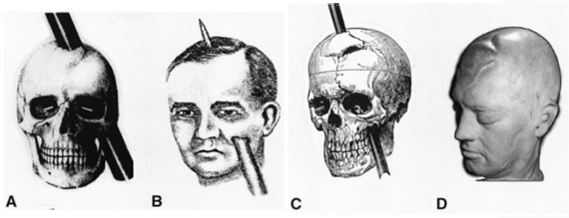

However, although Phineas had a varied employment history, he did hold a number of responsible positions during it. According to Dr. Harlow, Phineas appeared at Barnum's American Museum in New York City, worked in Jonathan Currier’s livery stable at the Dartmouth Hotel (Hanover, NH), and drove coaches and cared for horses in Valparaiso, Chile. In about 1859, after his health began to fail, he went to San Francisco to live with his family who had moved there from Lebanon (NH) at the beginning of the gold-rush. After Phineas regained his health he was anxious to work and found it on a farm in Santa Clara County, south of San Francisco. In February 1860, he began to have epileptic seizures and, as we know from the Funeral Director's and cemetery interment records, he was buried on 23rd May 1860.
