Name:___________________________

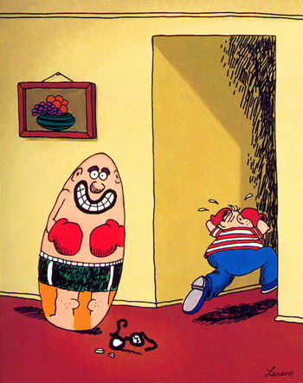
SG MODULE 17: Observational Learning

- Watch a video on Albert Bandura and the Bobo Doll Experiment. Explain the structure of the study and how consequences played into the results.

- Bandura theorized that we only learn when watching others under certain circumstances. What requirements must be met in order to learn from others? Explain these in your own words.

- The Importance of Modeling: Can people choose to be role models? Explain prosocial and antisocial role models and the types of behaviors they exhibit.

  - Who are your role models? Which ones do you think are:

Prosocial Antisocial

- What is the connection between media violence and real life?

- Complete the following statement: I believe the average U.S. student has witnessed about __________ murders and well over _______________ violent acts the end of the elementary school.

- Summarize the conclusions of the Commissions on Violence and Youth from the article. Does this match what you see?

